**Date:20/10/2020**

**Practical no 8**

**AIM:** Write and test a program to count the number of check boxes on the page checked and unchecked count.

**Theory**

**WebElement** : Represents an HTML element. Generally, all interesting operations to

do with interacting with a page will be performed through this interface.

WebElements objects are Selenium(Java) equivalent of HTML elements in the UI such

as Form, Button, Select, A, P, H0-6, etc..

**java.util.List<WebElement>** : This data structure allows one two list down WebElements in Java which could be sub-elements or nested elements under the selector. The object has methods such as object.size() which returns the size of the list,

object.get(index) which returns a element from the object at a specified index, object.get(index).getText() returns the text of the element.

**WebDriver.findElement() :** Find the first WebElement using the given method.

This method is affected by the ’implicit wait’ times in force at the time of execution. The

findElement(..) invocation will return a matching row, or try again repeatedly until the

configured timeout is reached. findElement should not be used to look for non-present

elements, use findElements(By) and assert zero length response instead.

**By.tagName()** : By is a mechanism used to locate elements within a document from

selenium code. This allows us to access elements by multiple ways such as tag names, ids,

names, class names, etc.. Here we use By.tagName() to select HTML elements through

specified tag name.

**Code:**

**Part A**

|  |
| --- |
| **import** java.util.List;  **import** org.openqa.selenium.By;  **import** org.openqa.selenium.WebDriver;  **import** org.openqa.selenium.WebElement;  **import** org.openqa.selenium.chrome.ChromeDriver;  **public** **class** Prac8 {  **static** String *driverPath*="E:\\tycs\\stqa prac\\prac2\\chromedriver_win32\\chromedriver.exe";  **public** **static** **void** main(String[] args) **throws** InterruptedException {  System.*setProperty*("webdriver.chrome.driver", *driverPath*);  WebDriver driver= **new** ChromeDriver();  //driver.get("http://www.ironspider.ca/forms/checkradio.htm");  driver.get("http://www.echoecho.com/htmlforms09.htm");  //driver.get("file:///E:/tycs/stqa%20prac/prac8/radio.html");  List<WebElement> checkboxes = driver.findElements(By.*xpath*("//input[@type = 'checkbox']"));  **for**(**int** i = 0 ; i<checkboxes.size() ; i=i+1)  {  checkboxes.get(i).click();  }  System.***out***.println("performed by krunal dhavle 713");  **int** checkedCount = 0 , uncheckedCount =0;  **for**(**int** i =0 ; i < checkboxes.size() ; i++)  {  System.***out***.println(i + " " + "checkboxes is selected : "+checkboxes.get(i).isSelected());  **if**(checkboxes.get(i).isSelected())  checkedCount++;  **else**  uncheckedCount++;  }  Thread.*sleep*(5000);  System.***out***.println("number of selected checkedboxes " + checkedCount);  System.***out***.println("number of unselected checkedboxes " + uncheckedCount);  driver.close();  }  } |

**Output:-**

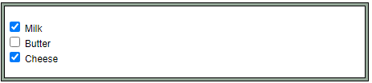

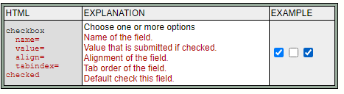

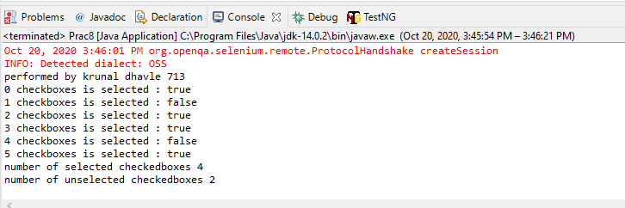

**Part -2**

|  |
| --- |
| **import** java.util.List;  **import** org.openqa.selenium.By;  **import** org.openqa.selenium.WebDriver;  **import** org.openqa.selenium.WebElement;  **import** org.openqa.selenium.chrome.ChromeDriver;  **public** **class** Prac8 {  **static** String *driverPath*="E:\\tycs\\stqa prac\\prac2\\chromedriver_win32\\chromedriver.exe";  **public** **static** **void** main(String[] args) **throws** InterruptedException {  System.*setProperty*("webdriver.chrome.driver", *driverPath*);  WebDriver driver= **new** ChromeDriver();  driver.get("file:///E:/tycs/stqa%20prac/prac8/radio.html");  List<WebElement> checkboxes = driver.findElements(By.*xpath*("//input[@type = 'checkbox']"));  **for**(**int** i = 0 ; i<checkboxes.size() ; i=i+2)  {  checkboxes.get(i).click();  }  System.***out***.println("performed by krunal dhavle 713");  **int** checkedCount = 0 , uncheckedCount =0;  **for**(**int** i =0 ; i < checkboxes.size() ; i++)  {  System.***out***.println(i + " " + "checkboxes is selected : "+checkboxes.get(i).isSelected());  **if**(checkboxes.get(i).isSelected())  checkedCount++;  **else**  uncheckedCount++;  }  Thread.*sleep*(5000);  System.***out***.println("number of selected checkedboxes " + checkedCount);  System.***out***.println("number of unselected checkedboxes " + uncheckedCount);  driver.close();  }  } |

**Output:-**

